LAB Assignment
(SEQUENTIAL FILES, COBOL and JCL)

SSB BOOTCAMP

SEED

GDSS

LAB Assignments Series (Sequential files and JCL)

Assignment 1

The problem
XYZ Corporation receives a data file every day from an external source. The data file has the following layout. There is no sorting order present in the file

Nature of data | Data Type | Data Length
Account number | Numeric | 6
Account Name | Character | 20
Account Pin Code | Character | 6
Credit Debit Indicator | Character containing ‘C or ‘D’ | 1
Account Balance | Numeric | (9,2)
Overdraft limit | Numeric | (5,2)
Whether has credit card | Character containing ‘Y’ or ‘N’ | 1
Whether has private banking status | Character containing ‘Y’ or ‘N’ | 1
Whether joint or single | Character containing ‘J’ or ‘S’ | 1

XYX Corporation needs to carry out the following processing with the file

Task 1
Generate a report that shows all the people who have account balance more than 100,000. This report should be sorted on the account number and layout should be as given below

Format of Report
-------------------------------------------------------------------------------
ACC NO ACCOUNT NAME & PIN BALANCE OD LIM CR CARD PVT CUS JT/SINGLE
-------------------------------------------------------------------------------
XXXXXX XXXXXXXXXXXXXXXXXXXX +XXXXXXXXX.XX XXXXX.99 X X X
XXXXXX

Task 2
Generate a report that has a list of all people who have more than Rs. 20,000 account balance but are not having a credit card. Report should be sorted on Pin code and account number. On every change on pin code the following should happen
It should print the following lines for the pin code

TOTAL NUMBER OF ACCOUNT HOLDERS IS 999999
TOTAL BALANCE OF ACCOUNT HOLDERS IS 999999999.99

Also the same summary should be printed at the end of the report for all the customers

Task 3
A new sequential file of transactions is input that has the following layout

Nature of data | Data Type | Data Length
Account number | Numeric | 6
Credit Debit Indicator | Character containing ‘C or ‘D’ | 1
Transaction Amount | Numeric | (9,2)

Merge this information with the main data file to produce a new main data file that should have the balances updated with the result of the transaction. The transactions relate to deposits and withdrawals on the accounts.

Flowchart of Merge process
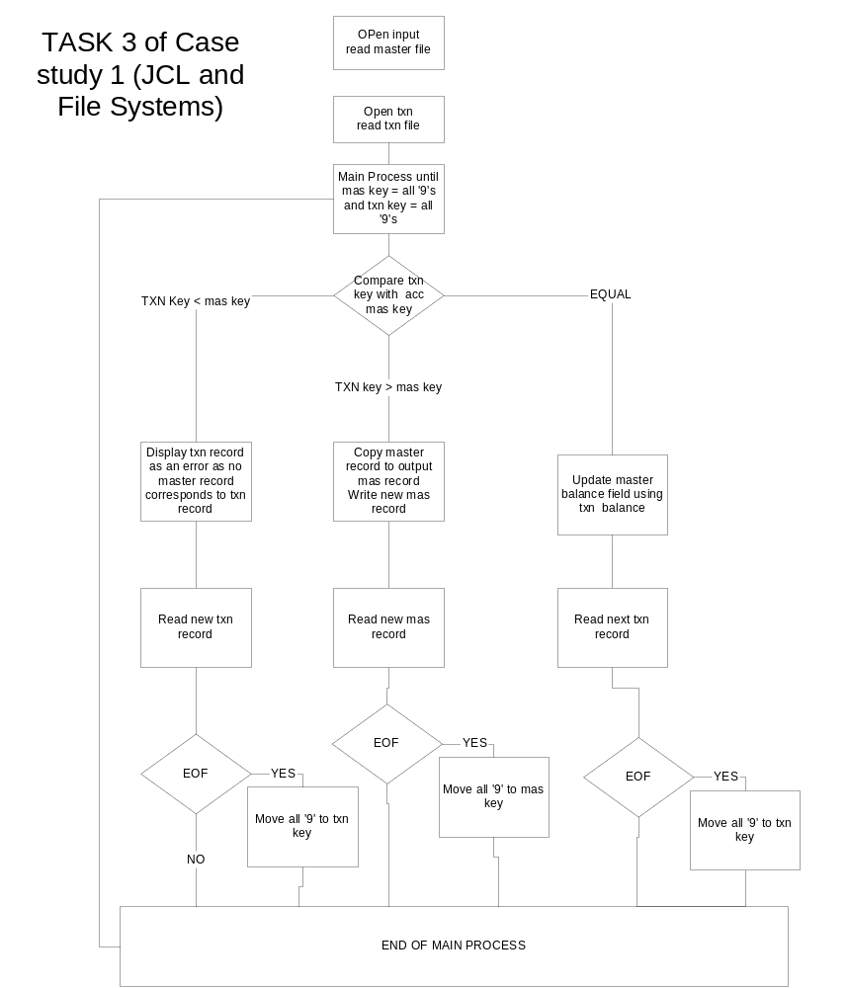
Deliverables for each task

- JCL
- COBOL Code
- Job log of run (consult with faculty as to how to download the same onto PC
- Test Plan and Test logs (as per GDSS Quality formats)
- Input file(s)
- Output files(s)

All files must be downloaded to the PC and zipped

Naming conventions

Each trainee will create all files with prefix of his mainframe user id. Thus for example if the mainframe user id is GDSS001

All partitioned datasets created by the teams must start with
- GDSS.*

There will be the following partitioned datasets created for each team

- GDSS001.CASEm.TASKi.COBOL
- GDSS001.CASEm.TASKi.JCL
- GDSS001.CASEm.TASKi.COPYLIB

Also all sequential files created (both input and output must have the following format

- GDSS001.CASEm.TASKi.SEQ.<name of file>

(n = group 1,5, m= case study number will be 1 for this case study, i will be the task number that can take values 1 to 3)

All JCL should be restartable and hence must delete all output and any temporary files before start of execution (Hint use IEFBR14)

